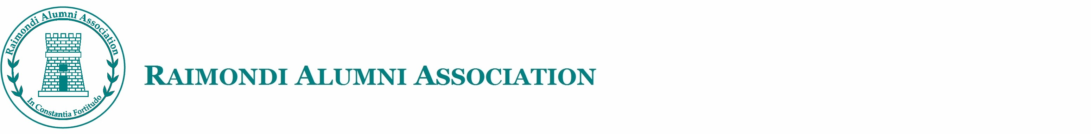

# Candidate

**Election of the Executive Committee Member**

**for the Raimondi Alumni Association Limited**

**(2024-2026)**

# Nomination Form

(Please fill in the form in BLOCK LETTERS)

Part A

Full Name (Eng): (Chi): Last Year at Raimondi College: (Primary/Form/Secondary: ) Contact Phone No: E-mail:

Declaration (Please tick “✓” as appropriate):

□ I hereby declare that my candidacy is in compliance with the requirements set out in the section 16A of the Articles of Association of the Raimondi Alumni Association Limited.

□ I hereby authorize the Secretary of the Raimondi Alumni Association Limited to verify any of the information given herein whenever required.

Signature of Candidate: Date:

# Proposer

Full Name (Eng): (Chi): Last Year at Raimondi College: (Primary/Form/Secondary: ) Contact Phone No: E-mail:

Declaration (Please tick “✓” as appropriate):

□ I hereby declare that I am an Incumbent Committee Member of the Raimondi Alumni Association Limited in 2022-2024.

□ I hereby authorize the Secretary of the Raimondi Alumni Association Limited to verify any of the information given herein whenever required.

Signature of Proposer: Date:

# Seconder

Full Name (Eng): (Chi): Last Year at Raimondi College: (Primary/Form/Secondary: ) Contact Phone No: E-mail:

Declaration (Please tick “✓” as appropriate):

□ I hereby declare that I am a Member of the Raimondi Alumni Association Limited.

□ I hereby authorize the Secretary of the Raimondi Alumni Association Limited to verify any of the information given herein whenever required.

Signature of Seconder: Date:



**Election of the Executive Committee Member**

**for the Raimondi Alumni Association Limited**

**(2024-2026)**

# Nomination Form

(Please fill in the form in BLOCK LETTERS)

Part B

1. Self-introduction of candidate:
2. Why do you want to be an Executive Committee Member of the Association?



1. Which aspect have you contributed to the Association recently?
2. How will you add value to the Association in the future?
3. Please indicate your preference for participating in the following sub-committees.

|  |  |  |
| --- | --- | --- |
|  | Sub-Committee | Priority |
| A. | Heritage |  |
| B. | Innovation |  |
| C. | Young Members |  |
| D. | Publications |  |
| E. | Professional Network |  |
| F. | Sports |  |
| G. | Fund-raising |  |
| H. | Sustainable Development |  |

*Note: The personal information provided above will be used for matters related to this election and thereafter restricted to the internal use of the Raimondi Alumni Association Limited only.*